W1 PRACTICE
PART 2 – MANIPULATION

 Before this practice
- You need to have completed: PART 1- EXPLORATION

 Learning objectives
- Apply type inference for variable declarations.
- Handle nullable and non-nullable variables.
- Differentiate between final and const.
- Manipulate strings, lists, and maps.
- Use loops and conditions to control flow.
- Define and call functions with positional and named arguments, understand arrow syntax



 Are you lost?
Read the following documentation to be ready for this practice:

- Variables
- Null Safety
- Built-in types
- Lists
- Loops
- Conditions
- Functions

REVIEW PART-1
In group of 3 or 4, review the self-learning work.
- After discussing with your peer, update your answers if you need
- Some groups will present their outcome to the classroom

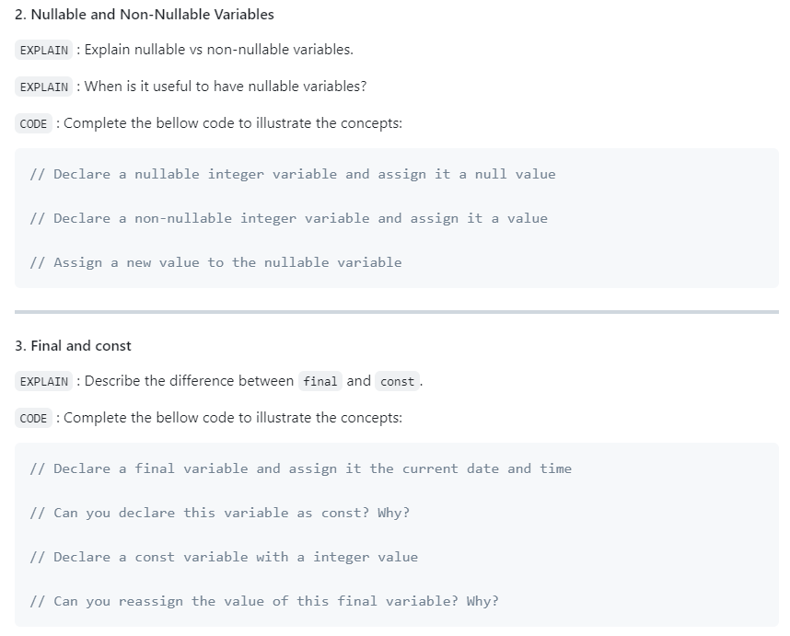
Review, and update your answer regarding your work

EX 1 – Manipulate Types
Are you clear about strings, integer, list, map, set, objects in Dart?
Examine the given data structures and write the inferred Dart type for each one (see example)

Notes
- First find by yourself the type
- If you need, double check your answer with VSCode.

Data | Dart Type
const studentGrades = {  'Sokan': [90, 85, 88],  'Sokea': [70, 80, 75],  'Hay': [95, 92, 89],  }; | Map<String, List<int>>
const pizzaPrices = {  'margherita': 5.5,  'pepperoni': 7.5,  'vegetarian': 6.5,  }; | Map<String, double>
const books = [  {'title': '1984', 'author': 'George Orwell'},  {'title': 'Brave New World', 'author': 'Aldous Huxley'},  {'title': 'Fahrenheit 451', 'author': 'Ray Bradbury'},  ]; | List<Map<String, string>>
const company = {  'HR': {'employees': 5, 'budget': 20000},  'IT': {'employees': 10, 'budget': 50000},  'Marketing': {'employees': 7, 'budget': 30000},  }; | Map<String, Map<String, int>>
const coordinates = [  [1, 2],  [3, 4],  [5, 6],  ]; | List<List<int>>
const productDetails = {  'id': 101,  'name': 'Laptop',  'price': 999.99,  'inStock': true,  }; | Map<String, Object>
const operations = [  (int a, int b) => a + b,  (int a, int b) => a - b,  (int a, int b) => a * b,  ]; | List<int Function(int, int)
const distances = {3.1, 5.5, 10.2, 7.8}; | Set<double>
const university = {  'departments': [  {  'name': 'Computer Science',  'students': [  {'name': 'Alice', 'age': 22},  {'name': 'Bob', 'age': 24},  ]  },  {  'name': 'Mathematics',  'students': [  {'name': 'Charlie', 'age': 21},  {'name': 'Dave', 'age': 23},  ]  }  ]  }; | Map<String, List<Map<String, Object>>>

EX 2 – Manipulate final and const
In this exercise, you need to decide which variable can be declared as const or final.

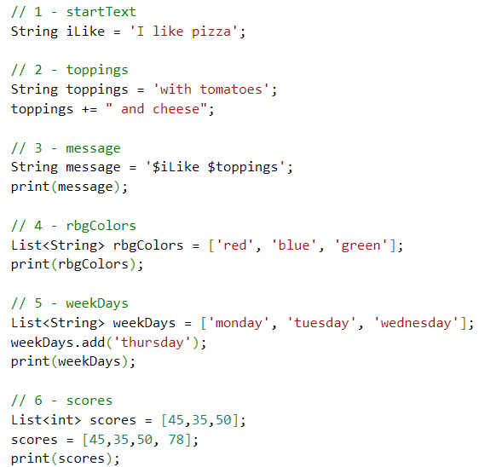

Guess which variables can be declared as const, final or var, and explain your choices.
Notes
- Read here to understand the concepts.
- Prefer const over final over var.

 | VAR, FINAL, CONST? | WHY
iLike | CONST | Because this variable never changes
toppings | Var | Because it will be added with another string
message | final | Because it will be initialized in run time
rbgColors | const | Because it will never change
weekDays | Final | Because it is better than var but it can be mutable
score | Var | Because it will be changed later

EX 3 – Filter a list

Instructions
- You are given a list of integers representing the scores of students in an exam.
- A score of 50 or higher is considered passing.
- Write a Dart program that filters and returns a list of students and the number of students who passed the exam.

Constraints
- You must use the where function with a proper anonymous function to filter the original list
- More information here

Examples
INPUT
[45, 78, 62, 49, 85, 33, 90, 50]

OUTPUT
[78, 62, 85, 90, 50]
5 students passed

EX 4 – Manipulate maps
Given the following map of pizza prices:

const pizzaPrices = {
'margherita': 5.5,
'pepperoni': 7.5,
'vegetarian': 6.5,
};

Write a program to calculate the total for a given order.

For example, given the following order:
const orders = ['margherita', 'pepperoni'];

The program should print:
Total: $13`

If a pizza is not on the menu, the program should print:
pineapple pizza is not on the menu



HOMEWORK 1 – Write a robot simulator

A robot factory's test facility needs a program to verify robot movements.
The robots have three possible movements:
- turn right
- turn left
- advance

Robots are placed on a hypothetical infinite grid, facing a particular direction (NORTH, EAST, SOUTH, OR WEST) at a set of {X, Y} coordinates, e.g., {3,8}, with coordinates increasing to the north and east.

The robot then receives a number of instructions, at which point the testing facility verifies the robot's new position, and in which direction it is pointing.

As example
- the string "RAALAL" means:
- Turn right
- Advance twice
- Turn left
- Advance once
- Turn left yet again

- Say a robot starts at {7, 3} facing north.
- Then running this stream of instructions should leave it at {9, 4} facing west.

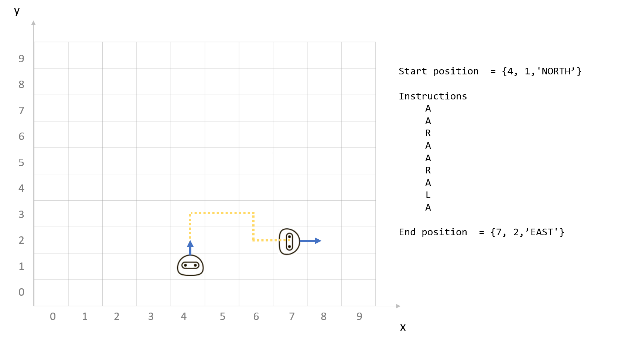

Note
- You are free to decide how to structure your data in Dart language
- Try to use as much as possible functions to separate your logic

HOMEWORK 2 – Matching Brackets

Instructions
Given a string containing brackets [], braces {}, parentheses (), or any combination thereof, verify that any and all pairs are matched and nested correctly. Any other characters should be ignored.

Examples
INPUT | OUTPUT
{what is (42)}? | Balanced
[text} | Not balanced
{[[(a)b]c]d} | Balanced

